

**NEW WEEKLY JOB POSTINGS FROM   
HELP WANTED ONLINE  
Office of Research**

**Week Ending June 24th, 2023 Total New Ads Down 27% From Two Weeks Ago**WETHERSFIELD, June 27th, 2023 – During the week ending June 24th, 2023, there were 5,003 new postings in Connecticut. This total new ad count is down 27% from two weeks prior during the week ending June 10th. Thirty-two percent of those postings occurred in three industries: Health Care & Social Assistance (787 new ads or 16%), Retail Trade (439 new ads or 9%), and Manufacturing (386 new ads or 8%). These three industries respectively had 211, 129, and 163 employers postings new ads. Among job ads with advertised salary information, Health Care job ads had a median annual income of $42,112, Retail Trade ads had a median of $39,552, and Manufacturing had a median of $46,464. The industry with the highest advertised median income within its new job ads was Professional, Scientific, & Technical Services ($92,544) and the lowest was Accommodation & Food Services ($35,968). The HWOL series recently migrated to a new data platform that has resulted in adjustments to its deduplication process. Due to this, comparison to weeks before the week ending June 3rd may be impacted by methodology differences.  
  
**Industries** with the most new postings include Health Care & Social Assistance, Retail Trade, and Manufacturing.

**Occupations** with the most new postings include Registered Nurses, Retail Salespersons, and Supervisors of Retail Salespersons

**Employers** with the most new postings include Child Guidance Center of Southern CT, Hartford HealthCare, and Yale New Haven Health.  
  
**Total New Job Ads by Occupation: Week Ending June 24th, 2023**



The above table highlights the 25 occupations with the most new job ads during the week ending June 24rd, 2023. During that week, employers posted new job ads for over 700 specific occupations in the state. The three occupations with the most new ads were Registered Nurses (271 new ads), Retail Salespersons (143 new ads), and Supervisors of Retail Sales Workers (130 new ads). Among the new ads that week, 1,897 had salary info for over 300 specific occupations. Those new ads with salary info had a median advertised salary of $48,000 per year or $23.08 per hour. Among the 25 occupations with the most new ads, five had advertised annual medians of over $100,000. The largest being Computer Occupations ($139,776), Sales Managers ($126,720), and Software Developers ($125,184). The occupations with the lowest median income in the top 25 include Fast Food & Counter Workers ($33,408), Retail Salespersons ($35,456), and Home Health & Personal Care Aides ($35,968).  
   
 For more information on total monthly job ads Connecticut and its labor market areas, see the monthly report available here: <https://www1.ctdol.state.ct.us/lmi/hwol.asp>

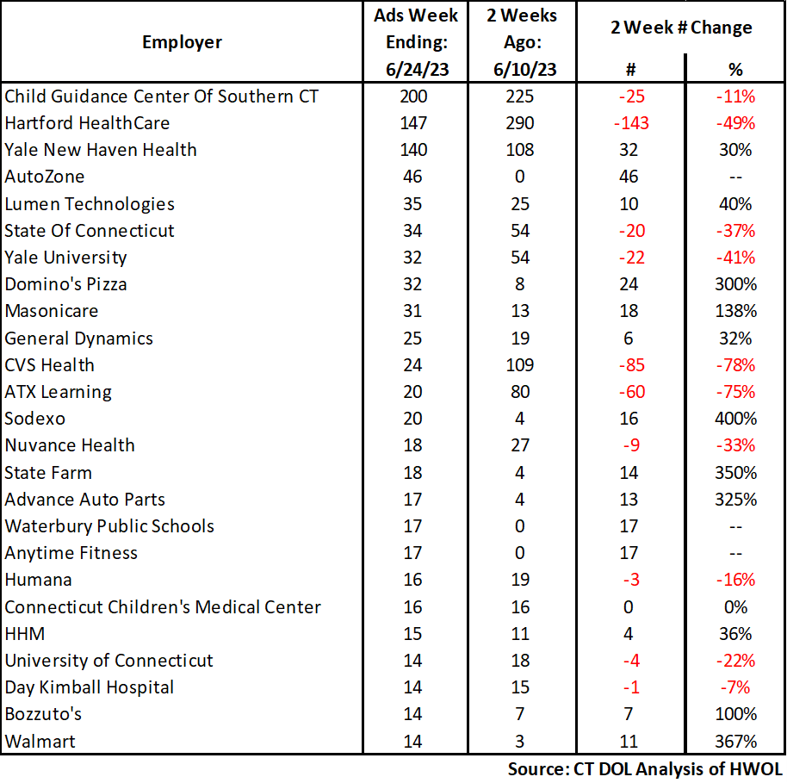 **Employers with the Most New Job Postings** Employers with the most new job postings during the week ending June 24th were mostly within Health Care & Social Assistance, Retail Trade, and Finance & Insurance. The employers with the most new ads in these three respective industries were Child Guidance Center Of Southern CT (200 new ads), AutoZone (46 new ads), and State Farm (18 new ads). Overall, the 25 employers with the most ads account for a combined 20 percent of total new ads.   **What is HWOL?**The **Conference Board Help Wanted Online**® Data Series (HWOL) measures the number of new, first-time Online job postings and jobs reposted from the previous month for over 16,000 Internet job boards, corporate boards, and smaller job sites that serve niche markets and smaller geographic areas. To view more HWOL data, go to: <https://www1.ctdol.state.ct.us/lmi/hwol.asp>